- When you arrive on the website, please click on the customer portal button as indicated in screenshot 1 with the red arrow. the red arrow. The orange pop-up will appear, please click on the text in the orange box which shows “are you already known to us?”. You will then be redirected to the page shown in screenshot 2, please enter your name and company name and click submit
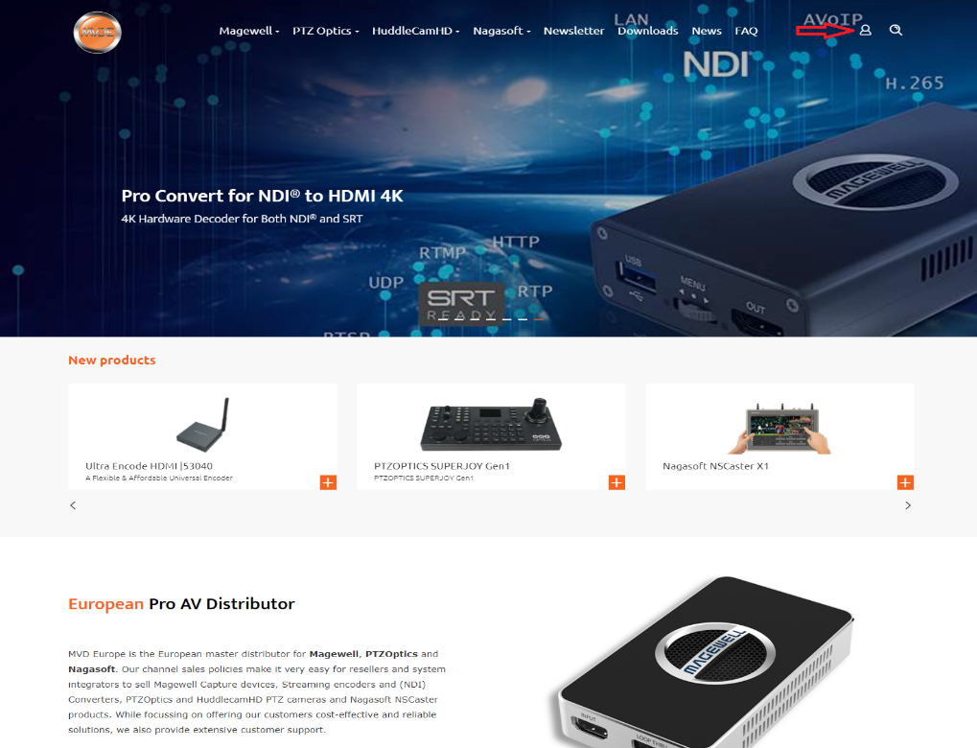

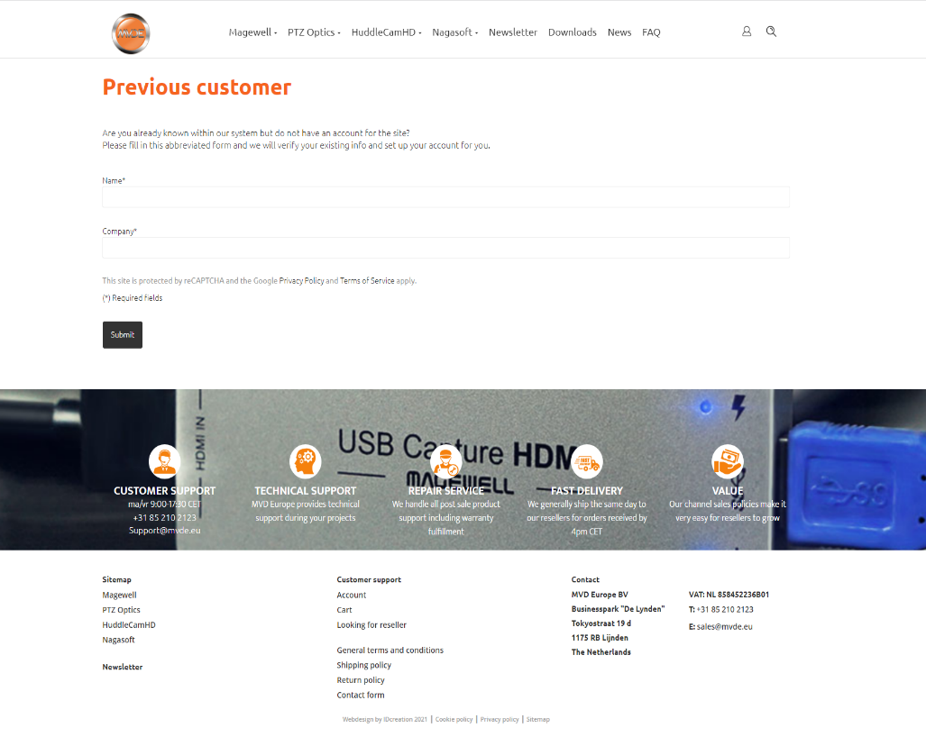

2. Once this is done, we will make a website account for your company, we will mail you back with login credentials for your first log-in on the website. After this, you will be able to change your password if you like to.
P.S. It is important to notice that only one account can be made per company.

By clicking on the customer portal button, you can now see three options, “account”, “orders”, and “logoff”.

3. Clicking on the “account” button will take you to your company information. Here you can change your addresses, main contacts, and other company info.
4. Clicking on “orders” will take you to the order history page. Here you can view the orders you made with the website. Together with the delivery notes and invoices.
5. Making an order as just as easy as any other online website.
P.S. It is important to note that the email address given when checking out, Is the email address where the invoice and delivery note will be mailed to. You can also find these documents back in the order history.

How to order?
- Select the quantity and click ‘add to cart’. The product availability is mentioned below. Please note: Due to fluctuations in demand it can happen sometimes that products are not available from stock. Despite this, customers will still be able to order the product. This order will be registered as a 'backorder'. We will inform you about the estimated delivery times shortly after your order has been placed.
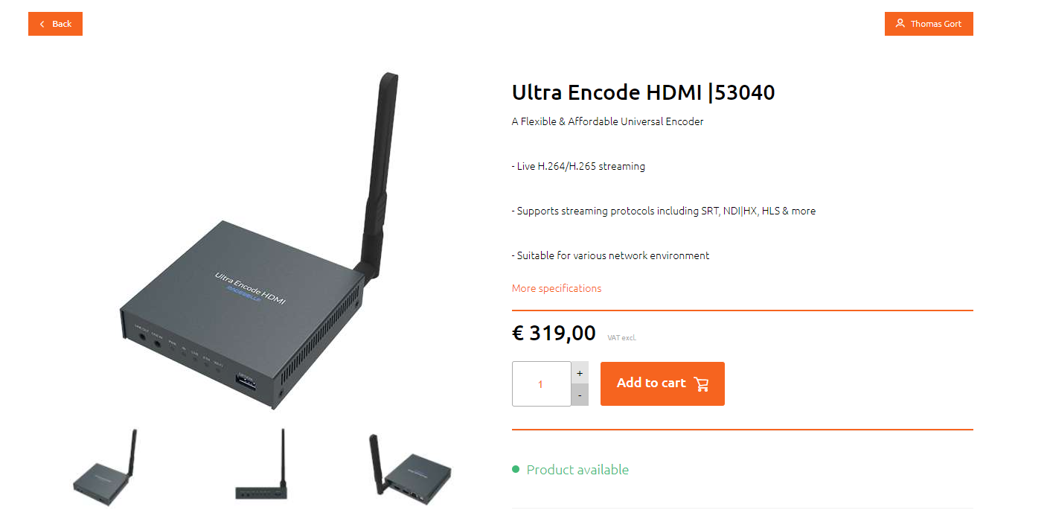

- After you added the product to your cart, the website will automatically direct you to your shopping cart. Quantities can still be adjusted here. Click on ‘order’ to proceed to the checkout.
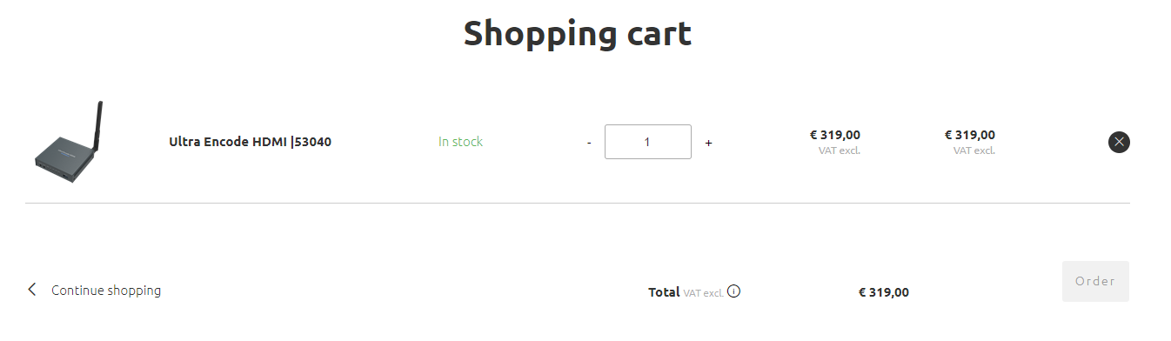

- Please review your contact information and billing address information. After that, please check the box ‘I agree to the general conditions’.

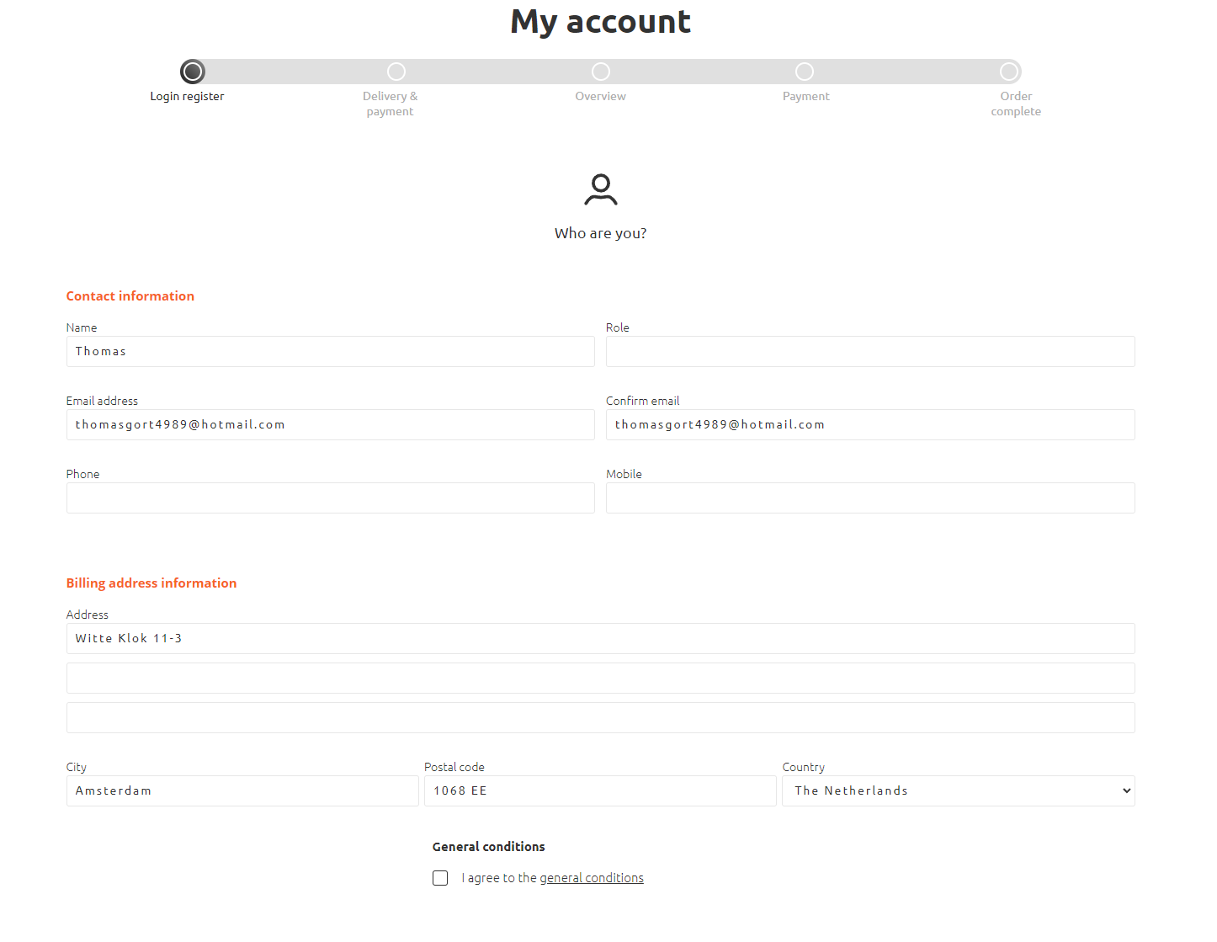

- Please enter your preferred shipping address. The checkout will provide the calculated shipping costs. Besides standard shipping method, customers have the option to select different express shipping methods as well.

If applicable, please submit your PO number in the ‘internal PO’ section!
Then click on ‘proceed’ to finalize the order.

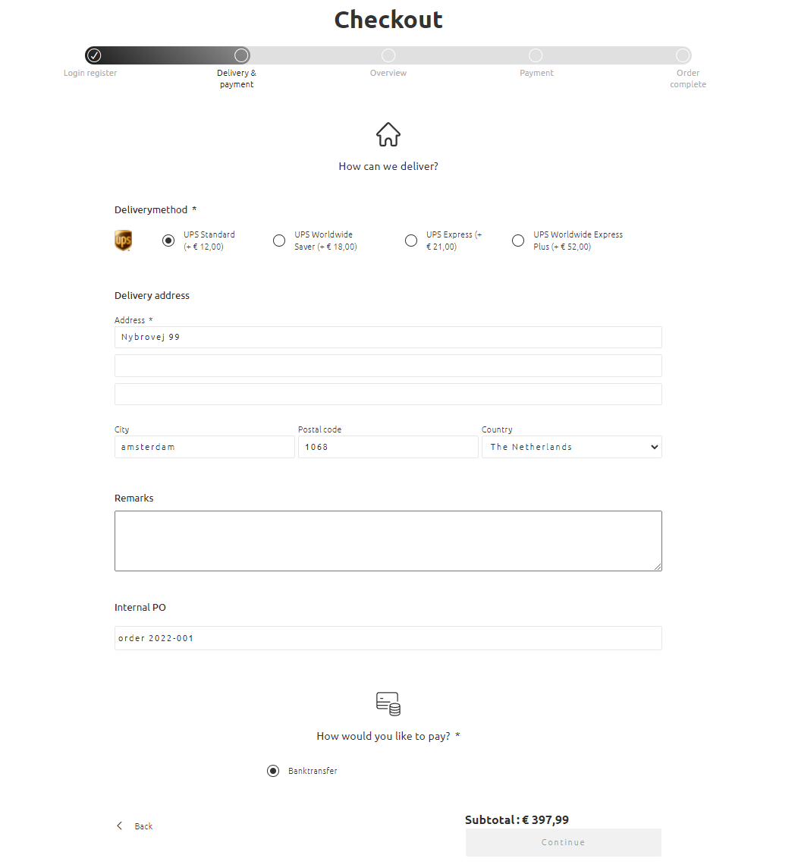

- Now you will see the final overview. Please check your information before sending the order!
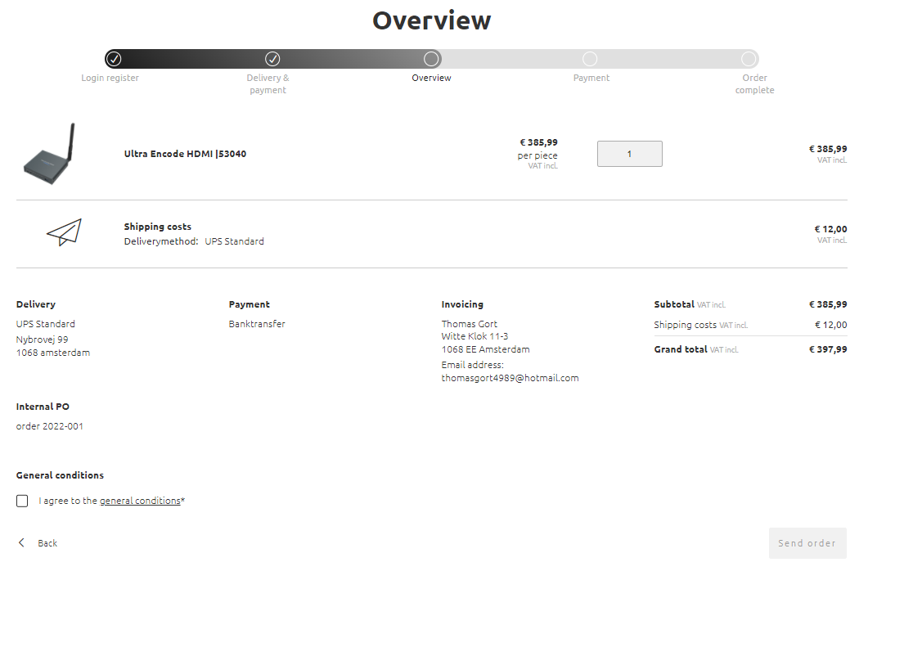
- Perfect, your order has been successfully submitted!! MVD Europe will now process your order as soon as possible. You will receive the invoice and delivery note by email after the order has been processed.
